SECONDARY



JHS

LEARNING STRAND 1

COMMUNICATION SKILLS IN ENGLISH

MODULE 8: WRITE IT (YOUR JOURNEY INTO THE TEXT)

ALS Accreditation and Equivalency Program: Junior High School

LEARNING STRAND 1

WRITE IT



YOUR JOURNEY INTO THE TEXT

##### COMMUNICATION SKILLS IN ENGLISH MODULE 8

**ALS Accreditation and Equivalency Program:** Junior High School

**Learning Strand 1:** Communication Skills in English

**Module 8:** Write It (Your Journey Into the Text)

Published in 2020 by the United Nations Educational, Scientific and Cultural Organization UNESCO Office, Jakarta

Jalan Galuh II No. 5, Kebayoran Baru, Jakarta, Indonesia

*and*

Department of Education

DepEd Complex, Meralco Avenue, Pasig City, Philippines Copyright © UNESCO and DepEd 2020

This publication is available in Open Access under the Attribution-Share Alike 3.0 IGO (CC-BY-SA) 3.0 IGO) license [(h](http://creativecommons.org/licenses/by-sa/3.0/igo/))t[tp://creativecommons.org/licenses/by-sa/3.0/igo/).](http://creativecommons.org/licenses/by-sa/3.0/igo/)) By using the content of this publication, the users accept to be bound by the terms of use of the UNESCO Open Access Repository (http://www.unesco. org/open-access/terms-use-ccbysa-en).

The designations employed and the presentation of material throughout this publication do not imply the expression of any opinion whatsoever on the part of UNESCO concerning the legal status of any country, territory, city or area or of its authorities, or concerning the delimitation of its frontiers or boundaries.

The selection and presentation of the material contained in this publication, as well as the opinions expressed herein are the sole responsibility of the authors and not necessarily those of UNESCO, nor do they commit the organization in any way.

This educational resource material was developed and printed through the project “Better Life for Out-of- School Girls to Fight Against Poverty and Injustice in the Philippines” with financial support from Korea International Cooperation Agency (KOICA).

Printed by APC Printers Corporation Printed in Makati City, Philippines

ISBN 888-888-8888-88-8

DEVELOPMENT TEAM



**Jenelyn Marasigan Baylon Kristine Lee S. Lumanog**

**Judy R. Mendoza Reyangie V. Sandoval Josephine C. Intino**

**Eric U. Labre Roderick P. Corpuz**

**Daisy Asuncion O. Santos Marilette R. Almayda**

**Ariz Delson Acay D. Cawilan**

**G. H. S. Ambat Tonisito M. C. Umali Leonor Magtolis Briones**



**Jaime Daroy Elizabeth Reyes Bernadette Sison Mildred Parbo**

**Ma. Teresita Medado**

Master Teacher I, ALS Task Force (On-detail)

Education Program Specialist II, ALS Task Force (On-detail) Project Development Officer III, Bureau of Learning Resources Education Program Specialist II, Bureau of Learning Resources

Senior Education Program Specialist, Bureau of Curriculum Development Senior Education Program Specialist, Bureau of Learning Resources Supervising Education Program Specialist, ALS Task Force

Chief Education Program Specialist, Bureau of Learning Resources Director III/Head, ALS Task Force

Officer-In-Charge, Office of the Director IV, Bureau of Learning Resources Assistant Secretary for Alternative Learning System Program

and Task Force

Undersecretary for Legislative Liaison Office, External Partnership Service and Project Management Service

Secretary

Author Content Expert

Admin and Finance Staff Project Lead

President

**Content and Language Evaluators and Instructional Design Reviewer**

**Jonathan V. Gochuico Julie Lumogdang Maria Teresa E. Prieto**

De La Salle University – Dasmariñas

Regional Office XII – SOCCSKSARGEN, Department of Education Schools Division Office of Kalinga, Department of Education



**Ade Sandra Rusyda Djamhur**

**Marmon Abutas Pagunsan Remegio Alquitran**

**Maria Karisma Bea Agarao**

**Mee Young Choi Shahbaz Khan**

Admin and Finance Assistant Project Assistant

National Project Consultant National Project Officer

National Programme Coordinator Head of Education Unit

Director and Representative

###### User’s Guide



***For the ALS Learner:***

Welcome to this Module entitled Write It (Your Journey Into the Text) under Learning Strand 1 Communication Skills in English of the ALS K to 12 Basic Education (BEC).

This module was designed to provide you with fun and meaningful opportunities for guided and independent learning at your own pace and time. You will be enabled to process the contents of the learning resource while being an active learner.

This module has the following parts and corresponding icons:



|  |  |
| --- | --- |
| ***Let’s Get to Know*** | This will give you an idea of the skills or competencies you are expected to learn in the module. |
| ***Pre-assessment*** | This part includes an activity that aims to check what you already know about the lesson. If you get all the answers correct (100%), you may decide to skip this module. |
| ***Setting the Path*** | This section provides a brief discussion of the lesson. This aims to help you discover and understand new concepts and skills. |
| ***Trying This Out*** | This comprises activities for independent practice to solidify your understanding and skills of the topic. You may check the answers to the exercises using the Answer Key at the end of the module. |
| ***Understanding What You Did*** | This includes questions that process what you learned from the lesson. |
| ***Sharpening Your Skills*** | This section provides an activity that will help you transfer your new knowledge or skill in real-life situations or concerns. |
| ***Treading the Road to Mastery*** | This is a task which aims to evaluate your level of mastery in achieving the given learning competency. |
| ***Don’t Forget*** | This part serves as a summary of the lessons in the module. |
| ***Explore More*** | In this portion, another activity will be given to you to enrich your knowledge or skill of the lesson learned. This also tends retention of learned concepts. |
| ***Reach the Top*** | This part will assess your level of mastery in achieving the learning competencies in each lesson in the module. |
| ***Answer Key*** | This contains answers to all activities in the module. |
| ***Glossary*** | This portion gives information about the meanings of the specialized words used in the module. |

At the end of this module you will also find:

|  |  |
| --- | --- |
| ***References*** | This is a list of all sources used in developing this module. |

The following are some reminders in using this module:

1. Use the module with care. Do not put unnecessary mark/s on any part of the module. Use a separate sheet of paper in answering the exercises.
2. Don’t forget to answer the Pre-assessment before moving on to the other activities included in the module.
3. Read the instruction carefully before doing each task.
4. Observe honesty and integrity in doing the tasks and checking your answers.
5. Finish the task at hand before proceeding to the next.
6. Return this module to your ALS Teacher/Instructional Manager/Learning Facilitator once you are through with it.

If you encounter any difficulty in answering the tasks in this module, do not hesitate to consult your ALS Teacher/Instructional Manager/Learning Facilitator. Always bear in mind that you are not alone.

We hope that through this material, you will experience meaningful learning and gain deep understanding of the relevant competencies. You can do it!

CONTENTS

|  |  |
| --- | --- |
| **Let’s Get to Know** | 1 |
| **Pre-Assessment** | 2 |
| **LESSON 1: I Support You** | 6 |
| Setting the Path | 6 |
| Trying This Out | 7 |
| Understanding What You Did | 8 |
| Sharpening Your Skills | 13 |
| Treading the Road to Mastery | 15 |
| **LESSON 2: Please Take Note** | 16 |
| Setting the Path | 16 |
| Trying This Out | 17 |
| Understanding What You Did | 18 |
| Sharpening Your Skills | 28 |
| Treading the Road to Mastery | 31 |

|  |  |
| --- | --- |
| **LESSON 3: What’s the Difference** | 32 |
| Setting the Path | 32 |
| Trying This Out | 33 |
| Understanding What You Did | 34 |
| Sharpening Your Skills | 39 |
| Treading the Road to Mastery | 43 |

CONTENTS

|  |  |
| --- | --- |
| **Don’t Forget** | 44 |
| **Reach the Top** | 45 |
| **Answer Key** | 48 |
| **Glossary** | 59 |
| **References** | 62 |

## LET’S GET TO KNOW



O

f the different communication skills (reading, listening/viewing, speaking, and writing), writing can be the most challenging. Maybe

some people are naturally gifted writers. For them, ideas just come easily and composing sentences seems to happen smoothly. But if you are one of those who struggle in expressing your thoughts in written form, is there something that you can do to improve your writing skills?

The answer is yes!

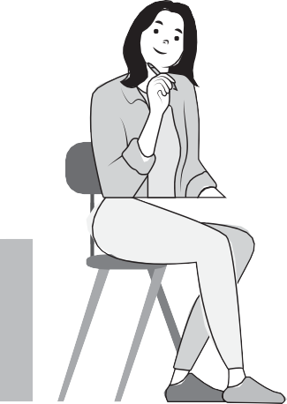

There are different ways to improve your writing skills. In this module, you will learn about the kinds of sentences that you need to construct to form a paragraph. This module will help you explore how you can vary your sentences to make your paragraph more effective and interesting to read. You will also learn the skill of notetaking—

the ability to identify key information from what you read or listened to and write them down as notes to aid you in your learning. Finally, you will be introduced to the three types of writing: informative, journalistic, and creative.

Writing could be challenging but with the help of this module, you will see that you can improve on this skill by learning some techniques and with constant practice.



PRE-ASSESSMENT

**Directions:** Today, you will answer a pre-test to measure your prior knowledge on this topic. Write the letter of the correct answer on a separate sheet of paper.

1. How many sentences does a paragraph contain?

|  |  |
| --- | --- |
| **A.** 1 sentence | **C.** 5–8 sentences |
| **B.** 3 sentences | **D.** 4 sentences |

1. The first sentence in a paragraph needs to be indented.
   1. True
   2. False
2. What is the name of the first sentence in a paragraph?

|  |  |
| --- | --- |
| **A.** Concluding sentence | **C.** Topic sentence |
| **B.** Supporting detail | **D.** Evidence |

1. What is the name of the last sentence in a paragraph?

|  |  |
| --- | --- |
| **A.** Topic sentence | **C.** Concluding sentence |
| **B.** Supporting detail | **D.** Evidence |

1. How many supporting details are needed to be included in a paragraph?

|  |  |  |  |
| --- | --- | --- | --- |
| **A.** 1 detail | **B.** 3 details | **C.** 4 details | **D.** 2 details |

1. Identify the transition word.

|  |  |  |  |
| --- | --- | --- | --- |
| **A.** therefore | **B.** and | **C.** the | **D.** is |

1. What are the five elements of a paragraph?
   1. 2 topic sentences, 3 supporting details
   2. 5 supporting details
   3. Topic sentence, 3 supporting details, concluding sentence
   4. 3 conclusion sentences, 1 topic sentence, 1 supporting detail
2. What sentence tells what your paragraph is going to be about?

|  |  |  |
| --- | --- | --- |
| **A.** Topic sentence | **B.** Supporting details | **C.** Concluding sentence |

1. What sentence summarizes the topic of the paragraph?

|  |  |  |
| --- | --- | --- |
| **A.** Supporting details | **B.** Topic sentence | **C.** Concluding sentence |

1. What is a paragraph?
   1. at least three sentences
   2. the middle part of a text
   3. a group of sentences that share the same idea

Determine the type of sentence for items 11–20.

1. The students like to read books.

|  |  |  |
| --- | --- | --- |
| **A.** Simple | **B.** Compound | **C.** Complex |

1. I like playing basketball, and my brother likes playing tennis.

|  |  |  |
| --- | --- | --- |
| **A.** Simple | **B.** Compound | **C.** Complex |

1. I'll help you if you help me.

|  |  |  |
| --- | --- | --- |
| **A.** Simple | **B.** Compound | **C.** Complex |

1. Her name is Lita and she comes from Manila.

|  |  |  |
| --- | --- | --- |
| **A.** Simple | **B.** Compound | **C.** Complex |

1. My mother cooked dinner while I was doing my homework.

|  |  |  |
| --- | --- | --- |
| **A.** Simple | **B.** Compound | **C.** Complex |

#### MODULE 8

1. While I was doing my homework, my father cooked the dinner and my mother was asleep in front of the television.

|  |  |  |
| --- | --- | --- |
| **A.** Simple | **B.** Compound | **C.** Complex |

1. Do you want to go swimming tomorrow, or would you prefer to play tennis?

|  |  |  |
| --- | --- | --- |
| **A.** Simple | **B.** Compound | **C.** Complex |

1. I’ve brought my umbrella with me in case it rains.

|  |  |  |
| --- | --- | --- |
| **A.** Simple | **B.** Compound | **C.** Complex |

1. She runs every day, so she is very fit.

|  |  |  |
| --- | --- | --- |
| **A.** Simple | **B.** Compound | **C.** Complex |

1. The new girl in our class has a brother in grade 7 and a sister in grade 9.

|  |  |  |
| --- | --- | --- |
| **A.** Simple | **B.** Compound | **C.** Complex |

1. It is a type of text which presents information that are found in radio, print, or television.

|  |  |  |
| --- | --- | --- |
| **A.** Informative | **B.** Literary | **C.** Journalistic |

1. It gives readers straightforward information about a topic.

|  |  |  |
| --- | --- | --- |
| **A.** Literary | **B.** Informative | **C.** Journalistic |

1. It is a type of text which is usually non-fiction.

|  |  |  |
| --- | --- | --- |
| **A.** Informative | **B.** Journalistic | **C.** Literary |

1. It is written originally by a writer.

|  |  |  |
| --- | --- | --- |
| **A.** Journalistic | **B.** Literary | **C.** Informative |

1. It is a type of text which is defined as a wide variety of imaginative and creative writing.

|  |  |  |
| --- | --- | --- |
| **A.** Literary | **B.** Journalistic | **C.** Informative |

1. It serves to inform or discloses information.

|  |  |  |
| --- | --- | --- |
| **A.** Journalistic | **B.** Informative | **C.** Literary |

1. It is a type of text which leads to the appreciation of the cultural heritage of students.

|  |  |  |
| --- | --- | --- |
| **A.** Literary | **B.** Journalistic | **C.** Informative |

1. It is a type of writing used to report news stories.

|  |  |  |
| --- | --- | --- |
| **A.** Literary | **B.** Journalistic | **C.** Informative |

1. It has a unique text type and construction level.

|  |  |  |
| --- | --- | --- |
| **A.** Informative | **B.** Literary | **C.** Journalistic |

1. It is a type of text in which the intention is to inform the reader about a specific topic.

|  |  |  |
| --- | --- | --- |
| **A.** Literary | **B.** Journalistic | **C.** Informative |

SETTING THE PATH



# I SUPPORT YOU

At the end of this lesson, you will be able to:

recognize/identify the parts of a simple paragraph (topic sentences, support sentences, conclusions) (LS1CS/EN-W-PSE-JHS-16); and

identify and write key ideas and supporting details (LS1CS/EN-W-PSE-JHS-17).



LESSON 1

TRYING THIS OUT

**Directions:** Read the following paragraph by Kara Mayer Robinson taken from the WebMD website. List down the sentences and answer the following questions. Write your answer on a separate sheet of paper.

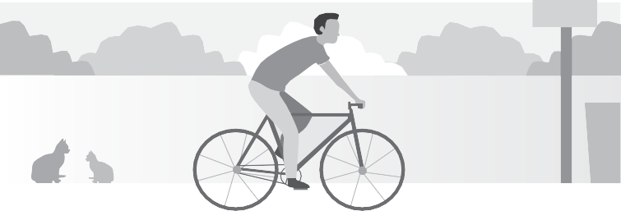

Biking is a top-notch cardio workout. You will burn about 400 calories an hour. Plus, it strengthens your lower body, including your legs, hips, and glutes. If you want a workout that is gentle on your back, hips, knees, and ankles, this is a great choice.

**Sentence #1**

**Sentence #2**

**Sentence #3**

**Sentence #4**

1. Which sentence best state what the paragraph is about?
2. Which of the sentences help clarify what the paragraph is about?
3. Which sentence sums up your answers in #1 and #2?

## UNDERSTANDING WHAT YOU DID

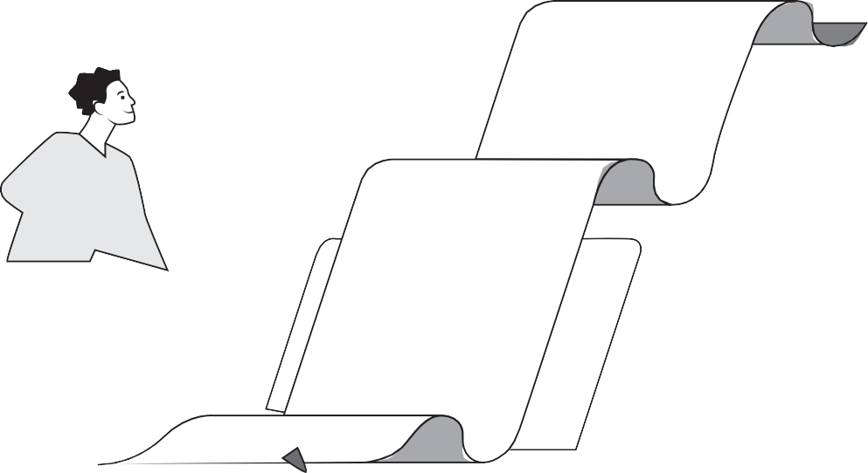

##### PARTS OF A PARAGRAPH

A **Paragraph** is a group of sentences. It forms the main structural component of a written text. Each paragraph focuses on a single idea that is connected to the main idea of the text. It has three basic parts: the topic sentence, supporting details, and the conclusion.

Topic sentence

In the previous activity, the sentence that best represents the topic of the paragraph is:

*Biking is a top-notch cardio workout.*

With this sentence, you get the idea that the paragraph discusses how biking is a good form of exercise. It can tell you what the paragraph is

about even if you remove the other sentences. We call this part of a paragraph as the **topic sentence.**

1

A topic sentence is usually the first sentence of a paragraph. Although it can also appear in other parts of the paragraph, placing it at the beginning is strategic. This way, readers can easily and immediately grasp the idea. It also sets the limitation on what will be covered within the paragraph.

As mentioned earlier, a topic sentence can tell what the paragraph is about even without the other sentences. However, more information will be needed to clarify or elaborate the topic. For example, the sentences in the previous activity that help clarify how biking is a good form of exercise are:

*You will burn about 400 calories an hour.* (additional data that supports the claim that biking is a good exercise)

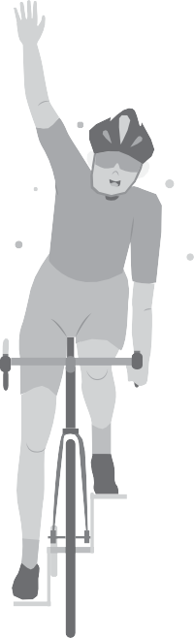

*Plus, it* (biking) *strengthens your lower body, including your legs, hips, and glutes.* (additional details that specify what biking does for which body part)

These sentences give evidence about how much calories biking burns in an hour and which part of the body it strengthens. These sentences in a paragraph are called **supporting sentences.**

Supporting sentences are used to develop the discussion in the paragraph. If topic sentences give a broad view of what the paragraph is about, supporting sentences are more specific. They provide evidence or information that supports the claim or the main idea of the paragraph. They usually contain statistics, data, facts, examples, reasons, and descriptions.

2

Finally, the sentence that sums up the key information from the topic sentence and the supporting sentences is:

*If you want a workout that is gentle on*

*your back, hips, knees, and ankles, this is a great choice*

(highlighted key information: biking is a good exercise)

This sentence emphasized how biking is a good exercise and how it impacts the body. It restates the topic and summarizes important points from the previous sentences.

This kind of sentence in a paragraph is called the **concluding sentence.** It usually appears at the end of the paragraph and highlights the key information mentioned earlier. It also signals the end of a paragraph and links it to the next. To help you locate the concluding sentence, you can watch out for transition words such as: all in all, in other words, in any event, in brief, in short, therefore.

3

Let’s look at another example:



Baskets serve as a national symbol for Filipinos. They are relevant to us agriculturally and culturally. It has been used as containers for Filipino farmers’ products or a status symbol of women from different indigenous groups. It is important to realize that by knowing more about these baskets, we can also learn more about our cultural identity as Filipinos (Razon & del Rio, 2018).

In this paragraph, the topic sentence is:

*Baskets serve as a national symbol.*

It states the author’s claim that baskets symbolize us as Filipinos. It is this statement that the following sentences elaborate:

*They* (referring to baskets) *are relevant to us agriculturally and culturally.*

(additional description of baskets)

*It* (baskets) *has been used as containers for Filipino farmers’ products or a status symbol of the women from different indigenous groups.*

(additional details to support the idea that baskets are relevant to us agriculturally and culturally)

Finally, the following sentence highlighted the key information from the previous sentences and emphasized the idea of the paragraph:

*It is important* (emphasis) *to realize that by knowing more about these baskets* (highlighted key information), *we can also learn more about our cultural identity as Filipinos* (highlighted key information).

###### Understanding What You Did



* Topic Sentence tells what the paragraph is about even if you remove the other sentences. It is usually the first sentence of a paragraph. It can also appear in other parts

of the paragraph. It also sets the limitation for what will be covered within the paragraph.

* Supporting Sentences are used to develop the discussion in the paragraph. They are more specific than the topic sentence. They provide evidence or information that

supports the claim or the main idea of the paragraph. They usually contain statistics, data, facts, examples, reasons, and descriptions.

* Concluding Sentence restates the topic and summarizes important points from the previous sentences. It usually appears at the end of the paragraph and highlights the

key information mentioned earlier. It also signals the end of a paragraph and links it to the next.

## SHARPENING YOUR SKILLS

1. Identify the topic sentence, supporting details, and conclusion in the paragraph below. Follow the table format as shown below. Write your answer on a separate sheet of paper.



We need clean water to survive. Sadly, it may run out one day. The good news is there are things we can do to help conserve clean, fresh water.

We can turn off faucets when not in use, we can fix leaks on water pipes or report to someone who can fix them, and we can also try to reuse and recycle water (American Museum of Natural History, n.d.). We need to constantly remind ourselves how valuable water is and start doing something to conserve it.

|  |  |  |
| --- | --- | --- |
| TOPIC SENTENCE | SUPPORTING SENTENCES | CONCLUDING SENTENCE |
|  |  |  |

1. Arrange the following sentences into a paragraph following the order: topic sentence, supporting details, and conclusion. Write your answer on a separate sheet of paper.

**Sentence #1**

More than a billion people live without enough safe, clean water.

**Sentence #2**

Clean fresh water is not always available where and when humans need it.

**Sentence #3**

In fact, half of the world's fresh water can be found in only six countries.

(**Source:** American Museum of Natural History website.)



TREADING THE ROAD TO MASTERY

Write your answers on a separate sheet of paper.

1. Choose one topic below and write a paragraph about it with five (5) sentences only.
   1. My favorite food
   2. What I love to do during summer
   3. What I like about our hometown
2. Identify the topic sentence, supporting sentences, and concluding sentence of your paragraph in Part I.
3. Topic sentence:

.

1. Supporting sentences:

.

.

.

1. Concluding sentence:

.

SETTING THE PATH



# PLEASE TAKE NOTE

At the end of this lesson, you will be able to:

write sentences on different issues, activities, or occasions (e.g., at home, in the community, in the workplace, local, national, international and international issues) (LS1CS/EN-W-PSE-JHS-5):

* simple sentences
* compound sentences
* complex sentences; and

take notes while reading a book or listening to a speaker/oral presentation (LS1CS/EN-W-PSE- JHS-32).



TRYING THIS OUT

**Directions:** Read carefully and identify whether the underlined word/phrase is a subject or a predicate. Write your answer on a separate sheet of paper.

Example:

A **1.** Maya planted a tree.

* 1. subject
  2. predicate

1. I love to bike and hike.
   1. subject
   2. predicate
2. Maya planted a tree, but it did not grow.
   1. subject
   2. predicate
3. I love to bike, so I always ride my bike to work.
   1. subject
   2. predicate
4. Maya was sad because the tree did not grow.
   1. subject
   2. predicate
5. When I ride my bike to work, I feel energized.
   1. subject
   2. predicate

## UNDERSTANDING WHAT YOU DID

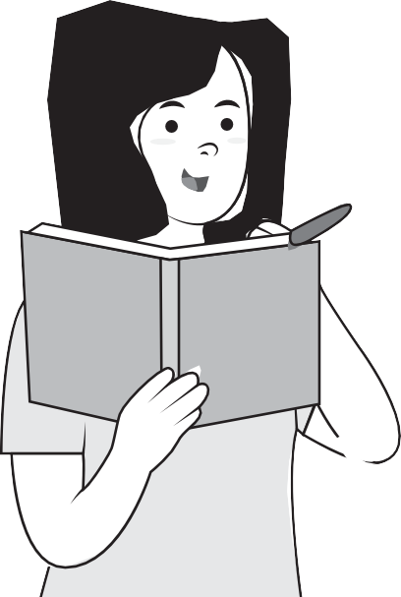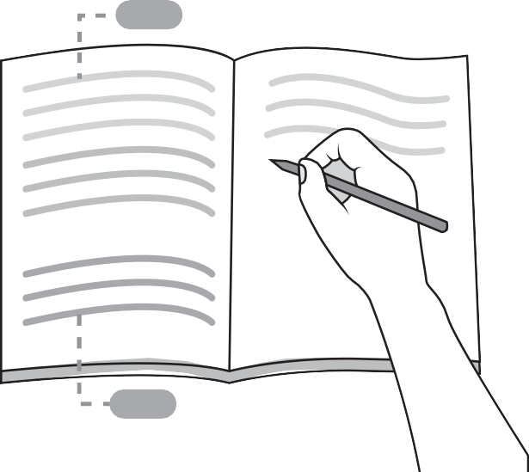

##### SENTENCE VARIETY

After knowing the different types of sentences and their roles within a paragraph, the next thing that you can learn is how to vary the structure of your sentences. Varying your sentences can make your paragraph clearer and more interesting to read.

There are three different types of sentences that you can use to achieve that variety in your paragraph. These are simple, compound, and complex sentences.

Before we discuss each type of sentences, let’s have a quick review of the basic elements of a sentence: the subject and the predicate. The subject is the person, place, or thing that a sentence is about. It usually contains a noun or pronoun and can include modifying words, phrases, or clauses. On the other hand, the predicate is the part of the sentence that describes the subject or tells what it is doing. It can contain the verb and modifying words, phrases, or clauses.

Now, let’s go back to the first sentence in our previous exercise:

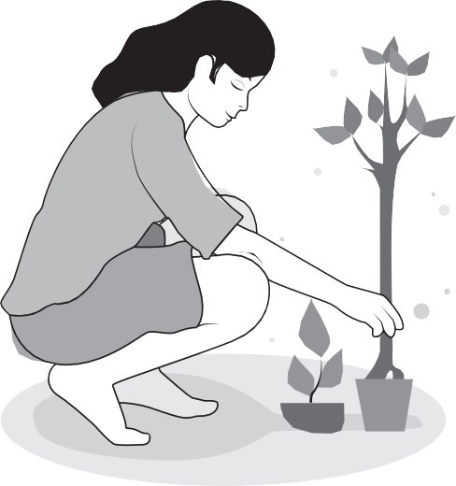*Maya planted a tree.*

*Maya* is the subject of the sentence. It is the noun that does the action, *planted a tree* (predicate). In the second sentence:

*I love to bike and hike.*

The phrase *love to bike and hike* is the predicate of the sentence because it tells us what *I*, the subject, loves to do.

What did you notice about the first two sentences? They are shorter compared to sentences #3 to #6. There is only one subject (*Maya* and *I*) and one predicate (*planted a tree* and *love to bike and hike*) in each sentence. This type is called a **simple sentence.**

**Simple sentences** are often short. They contain only the most basic elements of a sentence (subject and verb). They are considered as independent clauses because they give a complete thought. You can also find simple sentences as part of the other two types of sentences: compound and complex.



Let’s take a look at sentences #3 and #4:

*Maya planted a tree, but it did not grow.*

*I love to bike, so I always ride my bike to work.*

The underlined phrases *planted a tree* and *did not grow* are the predicates of these sentences. They refer to different subjects (*planted a tree* refers to *Maya* while *did not grow* refers to *it*).

In the fourth sentence, the underlined phrases *love to bike* and *always ride my bike to work* are the predicates of this sentence. They both refer to the subject *I*.

What did you notice about sentences #3 and #4? They are longer than the first and the second sentences. They contain more than one subject. They both have at least two predicates and they contain two complete statements:

*Maya planted a tree* (statement 1), *but it did not grow* (statement 2).

*I love to bike* (statement 1), *so I always ride my bike to work* (statement 2).

This type of sentence is called **compound sentence.** Compound sentences are two independent, complete statements combined to form a single sentence using a comma (,) or a semi-colon (;). The statements are connected by coordinating conjunctions: **f**or, **a**nd, **n**or, **b**ut, **o**r, **y**et, **s**o

You can easily remember these coordinating conjunctions using the acronym, FANBOYS.

F

A

N



B

O

Y

S

for

and

nor

but

or

yet

so

Finally, let us go back to sentences #5 and #6:

*Maya was sad because the tree did not grow.*

*Maya* is the subject of the predicate, *was sad*; while *tree* is the subject of the predicate, *did not grow.*

*When I ride my bike to work, I feel energized.*

The phrases *ride my bike to work* and *feel energized* are the predicates of the subject *I*.

What did you notice about sentences #5 and #6? They are also longer than the simple sentences (sentence #1 and #2). They have one or more subjects (*Maya, tree, I*) and at least two sets of predicates (*was sad, did not grow* and *ride my bike, feel energized*). They contain one complete statement (independent clause) and one incomplete statement (dependent clause).

*Maya was sad* (independent clause) *because the tree did not grow* (dependent clause). *When I ride my bike to work* (dependent clause),

*I feel energized* (independent clause).

This type of sentence is called a **complex sentence.** A complex sentence is a combination of a complete (independent clause) and an incomplete (dependent clause) statement.



A dependent clause is similar to an independent clause but it leaves one element to make it incomplete. It begins with subordinating conjunctions such as: *after, before, although, even, though, as, if, because, since,* and *though.*

For example, the statement *because the tree did not grow* (dependent clause) does not state what is the result of the tree not growing. The statement *when I ride my bike to work* (dependent clause) is incomplete because it does not tell what happens every time the subject rides bike to work.

Because of this dependence of one statement on another, complex sentences can indicate clearer and more specific relationship between main parts of the sentence. For example, before tells readers that one thing occurs before another.

LET'S PRACTICE

**Directions:** Identify the sentences whether simple, compound, or complex by checking the appropriate columns. Write your answer on a separate sheet of paper following the format below.

|  |  |  |  |
| --- | --- | --- | --- |
| OBSERVATIONS | SIMPLE | COMPOUND | COMPLEX |
| **1.** The baby drinks his milk. |  |  |  |
| **2.** JR answered his module, but JM was playing on his mobile phone. |  |  |  |
| **3.** After the lockdown, Kimper and Lan went to the yard and played. |  |  |  |
| **4.** They visited their grandmother because she was sick. |  |  |  |
| **5.** The parents returned the modules that were distributed last week. |  |  |  |

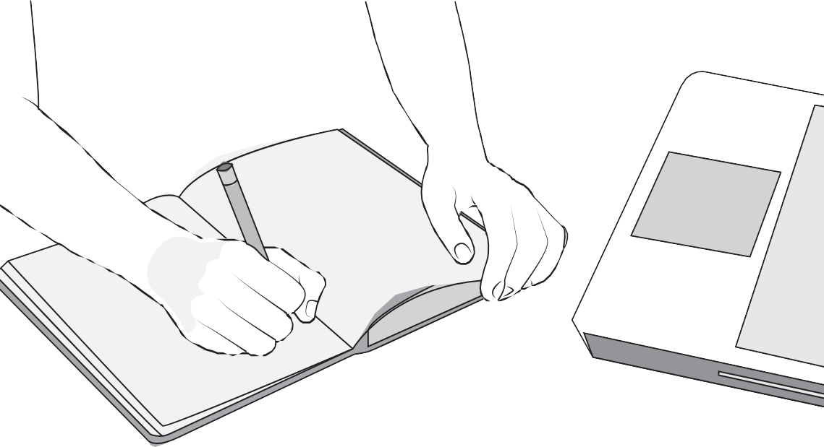

##### NOTE-TAKING

Going back to our previous activity, the nouns, verbs, and adjectives are some of the noteworthy details in the sentences. Determining what is being talked about (subject) in a written or spoken text and what is said about it (predicate) can help you decide what information to include when taking notes.

**Note-taking** is writing down key information from a book, a lecture, or other similar materials. As a student, well written notes are very useful when studying. It is an effective way to remember and understand what you have read, heard, or watched. It enables you to make better connections between ideas. In the long run, the practice of notetaking can build your organizational skill, boost your focus and attention span, improve critical thinking, and support memory retention.

But note-taking can be difficult for some students. Some of the challenges include overwhelming information and disorganized notes. The good thing is, there are methods that you can use to have well written notes.

In this module, we will only discuss three: outlining method, mapping method, and the sentence method.

Main topic

**·**

**·**

Subtopic #1

* key point 1
* key point 2
* key point 3

Subtopic #2

* key point 1
* key point 2

Main topic #2

**·**

Subtopic #2

* key point 1
* key point 2
* key point 3
* key point 4
* key point 5

The **Outlining Method** uses headings and bullet points to organize a topic. The main topic is written on the first line followed by the subtopic, which is listed on the next line. It should be indented as shown on the right. On the following lines, key points about the subtopic are written with one line allotted for each key point (see illustration). The next subtopic is written after the last key point of the previous subtopic.

This method is best when you are learning about topics with a lot of

details. Because notes are arranged by layers and according to their importance (from the main topic down to the key points), this method will help you to easily see the relationship between topics and subtopics. You can also easily turn points into study questions.

Let's look at some examples:

Baskets

national symbol for Filipinos

**·**

**·**

relevant to us agriculturally and culturally

○

○

used as containers for Filipino farmers' products

status symbol of the women from different indigenous groups

important: by knowing more about these baskets, we can also

learn more about our cultural identity as Filipinos

Clean water

needed to survive

**·**

**·**

**·**

may run out one day

there are things we can do to help conserve clean, fresh water

* We can turn off faucets when not in use
* We can fix leaks on water pipes or report to someone who can fix them
* We can also try to reuse and recycle water

We need to constantly remind ourselves how valuable water is and start doing something to conserve it.

Another method you can use when taking notes is the **mapping method.** When taking notes using this method, you begin by writing the main topic on your paper. Then, you branch out from the main topic to the subtopics as shown in the illustration. Write the key information about each subtopic below its header and continue as needed (see illustration).

If you learn better using illustrations or visuals like shown below, this method is for you. By drawing lines from the main topic to the subtopics, you can easily remember and connect the relationship between topics.

### Subtopic Subtopic



Keypoint #1

Keypoint #2

Keypoint #3

Keypoint #4

Main topic

Keypoint #1

Keypoint #2

Keypoint #3

Keypoint #4

### Subtopic Subtopic

Keypoint #1

Keypoint #2

Keypoint #3

Keypoint #4

### Subtopic

Keypoint #1

Keypoint #2

Keypoint #3

Keypoint #4

Keypoint #1

Keypoint #2

Keypoint #3

Keypoint #4

Here’s an example:

Relevant, agriculturally and culturally



* used as continers for Filipino farmers’ products
* status symbol of the women from different indigenous groups

BASKETS



National symbol for Filipinos

Important: by knowing more about these baskets, we can also learn more about our cultural identity

as Filipinos

You can also try the **sentence method.** In this method of notetaking, you simply write down each topic in sentence form as shown in the following illustration. Notice that each line on the page is a new and separate topic. You can organize your notes better if you use headings for each main topic.

Main topic

1. Sentence #1 about keypoint 1 of the main topic.
2. Sentence #2 about keypoint 1 of the main topic.
3. Sentence #3 about keypoint 1 of the main topic.

This method is most useful if you need to note down information in a hurry. It allows you to cover a lot of details and information quickly and have it simplified later for study and review.

***Remember:***

* + Only note down key statements or information.
  + Write down the:
    - introductory remarks or overview of the main topic;
    - signal words such as: there are for types to sum up

**·**

**·**

**·**

a major reason why

* + - * repeated words/concept; and
      * final remarks, summary.

**•**

Record the questions you want to clarify later.

###### Understanding What You Did



* + - * + Simple sentences contain only the most basic elements of a sentence (subject and verb). They form part of the basic components of the other two types of sentences:

compound and complex.

* + - * + Compound sentences are two independent, complete statements combined to form a single sentence using a comma (,) or a semi-colon (;). The statements are

connected by coordinating conjunctions.

* + - * + A complex sentence is a combination of a complete (independent clause) and an incomplete (dependent clause) statement.
        + When taking notes, only write down key statements or information.
        + Note-taking is a lifelong skill. It builds your organizational skill, boosts your focus and attention span, improves critical thinking, and supports memory retention.

LESSON 2

## SHARPENING YOUR SKILLS

Write your answers on a separate sheet of paper.

1. Identify which of the sentences is a Simple, Compound, or Complex sentence.
2. Waste segregation is a simple task.
3. Every time I go home, I help my parents watch our store.
4. I tried to cook, but I could not do it right.
5. My mother goes to the market every Sunday.
6. The students spoke, and the teacher listened.
7. Choose from the activities below and take notes based on the activity that you selected. Use the sample template for note-taking on page 30.
   1. Listen to what your teacher will read for you.
   2. Read the following essay taken from Philippine Institute of Volcanology and Seismology (PHIVOLCS) website

**Introduction to Earthquake**

**What is an Earthquake?**

An earthquake is a weak to violent shaking of the ground produced by the sudden movement of rock materials below the earth’s surface.

The earthquakes originate in tectonic plate boundary. The **focus,** sometimes called the **hypocenter,** is a point inside the earth where the earthquake starts, and the point on the surface of the

earth directly above the focus is called the **epicenter.**

There are two ways by which we can measure the strength of an earthquake: magnitude and intensity. **Magnitude** is proportional to the energy released by an earthquake at the focus. It is calculated from earthquakes recorded by an instrument called ***seismograph.*** It is represented by Arabic Numbers (e.g. 4.8, 9.0). **Intensity,** on the other hand, is the strength of an earthquake as perceived and felt by people in a certain locality. It is a numerical rating based on the relative effects to people, objects, environment, and structures in the surroundings. The intensity is generally higher near the epicenter. It is represented by Roman Numerals (e.g. II, IV, IX). In the Philippines, the intensity of an earthquake is determined using the PHIVOLCS Earthquake Intensity Scale (PEIS).

Types of earthquake

There are two types of earthquakes: tectonic and volcanic earthquakes. Tectonic earthquakes are produced by sudden movement along faults and plate boundaries. Earthquakes induced by rising lava or magma beneath active volcanoes are called volcanic earthquakes.

Earthquake Monitoring System

At present, PHIVOLCS operates 101 seismic monitoring stations all over the Philippines. These stations are equipped with seismometers that detect and record earthquakes. Data is sent to the PHIVOLCS Data Receiving Center (DRC) to determine earthquake parameters such as magnitude, depth of focus, and epicenter. Together with reported felt intensities in the area (if any), earthquake information is released once these data are determined.

#### LESSON 2

NOTE-TAKING WORKSHEET

|  |  |
| --- | --- |
| QUESTIONS  (Write the guide questions here) | NOTES |
| **1.** |  |
| **2.** |  |
| **3.** |  |
| **4.** |  |
| **5.** |  |
| SUMMARY: (Summarize all the key points here) | |



TREADING THE ROAD TO MASTERY

Write your answers on a separate sheet of paper.

1. Complete the sentences below using the words or statements provided.

Example:

* 1. Reading is a worthwhile activity.
  2. I love dogs but .
  3. When it rains, .
  4. I can plant a tree and my garbage properly.
  5. is an admirable characteristic.
  6. We conserve water because .
  7. Although , Amar and Fatima still decided to visit.
  8. It is amazing that you can cook while .
  9. Because everyone helped, the .
  10. Mildred segregates the , and John emptied the wastebin.

1. Choose one from the topics below and write a short paragraph (5 to 10 sentences only) about it using the different types of sentences. Use one or more simple sentence, one compound sentence, and one complex sentence.
2. The place I love the most
3. What I know about climate change
4. How I could help conserve water

SETTING THE PATH



# WHAT’S THE DIFFERENCE

At the end of this lesson, you will be able to:

distinguish between and among informative, journalistic, and literary writing (LS1CS/EN-W-PSE-JHS-23)

compose forms of literary writing (LS1CS/EN-W-PSE-JHS-24).



TRYING THIS OUT

**Directions:** Read the paragraphs below and answer the questions that follow. Write your answer on a separate sheet of paper.

Text #1

Coconut is the fruit of the coconut palm (Cocos nucifera), a tree of the palm family (Arecaceae). Coconuts probably originated somewhere in Indo-Malaya and are one of the most important crops of the tropics. Coconut flesh is high in fat and can be dried or eaten fresh. The liquid of the nut is used in beverages (Encyclopædia Britannica, Inc., 2020).

* 1. What is being described in text #1?

Text #2

Virgin coconut oil (VCO) trials may now be conducted on coronavirus patients of the Philippine General Hospital (PGH), the Department of Science and Technology (DOST) announced on Wednesday (CNN, 2020).

* 1. Identify the following information in text #2:
     1. WHAT is this sentence about?
     2. WHO are the individuals or group of individuals mentioned?
     3. WHERE will the event take place?
     4. WHEN did it take place?

**Text #3** (*Excerpt from Joyce Kilmer’s poem, “Trees”*) I think that I shall never see

A poem lovely as a tree.

*A tree whose hungry mouth is prest Against the earth’s sweet flowing breast;* A tree that looks at God all day,

And lifts her leafy arms to pray;

* 1. In text #3, what do you think does the phrase “hungry mouth” represent?

## UNDERSTANDING WHAT YOU DID

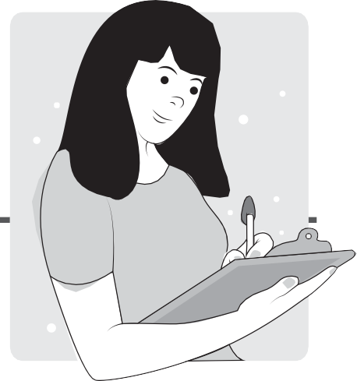

##### INFORMATIVE, JOURNALISTIC, LITERARY

What is being described in paragraph #1 is the tropical fruit, coconut. From the paragraph, which is an excerpt from an entry in the Encyclopædia Britannica, we learned that:

* *it is a fruit of the coconut palm (Cocos nucifera), a tree of the palm family (Arecaceae)*

**•**

*it probably originated somewhere in Indo-Malaya it is one of the most important crops of the tropics*

**•**

The paragraph further elaborates how *coconut flesh is high in fat and can be dried or eaten fresh, and that the liquid of the nut is used in beverages.* Notice how these statements tell us what a coconut is and specified some information about its different parts.

This paragraph, which was written to inform the readers about the given topic, is called **informative writing.** The output of this type of writing is called an informative essay or text. This is a subset of nonfiction piece of writing. It uses elements that help readers find information quickly and

efficiently such as: bold-faced and italicized words, embedded definitions for specialized vocabulary, realistic illustrations, captions, labels, graphs, charts. They are based on factual information and research. Just like this module!

Here are some steps you can take if you intend to write an informative text:

1. Plan what to write.



PLAN

1

2

4

3

Before you start writing the paragraphs of your essay or text, create an outline of what you want to cover. This way, you will know what information to look for or research about.

1. Research about your topic.

Make sure the information you include in your text are reliable and accurate with relevant evidence and examples.

1. Be familiar with a variety of sources.

These sources could include websites, books, journals, articles, or films. Know where to look for and how to access them. Remember that some sources do not offer the same information that is available in another type of source. For example, if you are looking for statistical data, do not expect to find them in narrative texts or texts that tells stories. Instead, turn your attention to research papers.

Let’s go back to the second task in our previous exercise:

*Identify the following information in text #2:*

WHAT is this sentence about?

The sentence is about the trial on virgin coconut oil (VCO) that may be conducted on coronavirus patients of PGH.

WHO are the individuals or group of individuals mentioned?

The organization mentioned in the sentence is the *Department of Science and Technology (DOST)*. It also mentioned *coronavirus patients of PGH.*

WHERE will the event take place?

This will take place in the Philippine General Hospital (PGH).

WHEN did it take place?

This took place on Wednesday.

This sentence, an excerpt of a news article taken from the CNN Philippines website, is an example of what is called **journalistic writing.**



. . .

Journalistic writing is characterized by conciseness and brevity or the use of short sentences and paragraphs. Journalistic texts are reports of an event, phenomenon, or occasion. In our previous exercise, the sentence is a report on the *trials on Virgin coconut oil (VCO) to be conducted on coronavirus patients of the Philippine General Hospital (PGH).*

The sentence (text #2) is the first sentence of the article where it was taken from. Notice how all the information (who, what, where, when) listed above are present in this first sentence of the article. This demonstrates what is called the **inverted pyramid** or the arrangement of information from the most important to the least. This arrangement of information is another characteristic of journalistic writing.

MOST IMPORTANT

LESS IMPORTANT

LEAST IMPORTANT

Journalist texts should be objective, fair, and balanced. They should be based on facts, not opinion. Finally, they should be written in active voice— the subject does the action stated by the verb. In the example we are using, the statement the Department of Science and Technology (DOST) announced on Wednesday, shows that the DOST does the action of announcing.



Finally, text #3 is an excerpt from the popular “Trees”, Joyce Kilmer’s 1913 poem. What the phrase, hungry mouth indirectly represents is the roots of the tree that absorbs the nutrients from the earth or the soil. This type of writing that is characterized as creative and imaginative is called **literary writing.**

Compared to its informative and journalistic counterparts, literary writing is more flexible or not bound by facts or data. Its primary purpose is to express, persuade, or entertain. This type of writing uses figurative or symbolic language to represent ideas or feelings.

There are different forms of literary writing. Some of them are poetry, stage plays, movie and television scripts, fiction (novels, novellas, and short stories), songs, speeches, memoirs, and personal essays.

###### Understanding What You Did



* An informative essay is a subset of nonfiction piece of writing. It uses elements that helps the readers find information quickly and efficiently such as: bold and

italicized words, embedded definitions for specialized vocabulary, realistic illustrations, captions, labels, graphs, charts. They are based on factual information and research.

* Journalistic writing is characterized by conciseness and brevity or the use of short sentences and paragraphs. Journalistic texts are reports of an event, phenomenon,

or occasion. It uses the inverted pyramid format of arranging information and it should be based on facts, not opinion.

* Compared to its informative and journalistic counterparts, literary writing is more flexible or not bound by facts or data. Its primary purpose is to express,

persuade, or entertain.

LESSON 3

## SHARPENING YOUR SKILLS

**Directions:** Read the excerpts of texts below and answer the questions that follow. Write your answer on a separate sheet of paper.



**Excerpt #1**

Teenagers rescued an old woman trapped and injured during the earthquake on Thursday in Estancia, Iloilo. Miguel Cadiz, Criselda Soberano, and Sahara Digos found 84-year old Remedios Julian struggle under the debris of an old building in Brgy. Ilaya while they were scanning the area for possible survivors. Julian is now stable and recovering in Estancia Medical Center while her rescuers continue to roam the ruins hoping to find more to rescue.

1. Which type of writing is this paragraph?
   1. Informative **B.** Journalistic **C.** Creative
2. Who are the people mentioned in this paragraph?
3. When and where did the event in the paragraph happen?
4. What is the paragraph about?

Excerpt #2



Philippine regional cinema is a collective term used to describe films or movies that were produced by Filipinos from different regions of the Philippines outside NCR (National Capital Region). Regional films may be classified into two groups. The first group is called the studio-produced regional films. They are produced by Large film studios or commercial production companies. The second group is classified as the independent films. They are produced by individuals or groups of filmmakers who are independent from the commercial film production companies.

1. Which type of writing is this paragraph?
   1. Informative
   2. Journalistic
   3. Creative
2. What is the paragraph about?
3. What are the two classifications of regional films?

#### LESSON 3



**Excerpt #3**

Once upon a time, there was a little girl named Kara. She lives with her grandparents in the mountain. She loves to plant trees and take care of her dogs and chickens. One day while she was feeding the chickens, Kara heard a voice from the tree beside their house. She came

closer to investigate where the voice is coming from. When she was very near the tree, she felt a very cool breeze embracing her. Then, she started to realize that she was slowly lifted from the ground by a force that she cannot see.

1. Which type of writing is this paragraph?
   1. Informative
   2. Journalistic
   3. Creative
2. Who is the main character in this story?
3. Where did the story take place?

**Excerpt #4**

If rhymes could free chained melody; And poems could seal one’s sympathy; Then hear this hum of prayer and plea; For souls to rest eternally.

1. Which type of writing is this stanza?
   1. Informative
   2. Journalistic
   3. Creative
2. What do you think is this stanza about? (Clue: For souls to rest eternally)



TREADING THE ROAD TO MASTERY

**Directions:** Compose a short piece of text for each type of writing. Write your answers on a separate sheet of paper.

1. Write an **informative essay** with 3 to 5 paragraphs only. Each paragraph must have 5 to 10 sentences. Mention where you get the information you included in your essay. Choose from the topics below:
   1. Pineapples and The Products You Can Make Out of It
   2. How to Segregate Waste
   3. Carlos P. Romulo
2. Write a **journalistic text** with 1 to 2 paragraphs. Each paragraph must have 3 to 5 sentences. Choose from the topics below:
   1. An event that recently happened in your town
   2. A person who recently arrived (or left) your town
   3. An accomplishment by anyone from your town
3. Write a **literary text** about your preferred topic. You may also choose from the following options below:

Topics:

1. Superpower
2. Special someone
3. Adventure

Forms:

1. short story
2. poem
3. personal essay

“

•

A paragraph has three parts: the topic sentence, the supporting details, and the conclusion. The topic sentence introduces the main idea of the paragraph. The supporting sentences give details to develop and support the main idea of the paragraph, and the concluding sentence restates the main idea of your paragraph.

* One of the most effective ways to remember and understand what you are learning in class is to take effective notes in the classroom. Better notes will help you remember concepts. It develops meaningful learning skills and gains a better understanding of a topic.



MODULE 8

DON’T FORGET

## REACH THE TOP



**Directions:** Read the paragraphs below and answer the questions that follow. Write your answer on a separate sheet of paper.

There are two types of earthquakes: tectonic and volcanic earthquakes. Tectonic earthquakes are produced by sudden movement along faults and plate boundaries. Earthquakes induced by rising lava or magma beneath active volcanoes is called volcanic earthquakes. It is important to understand the difference between these two types of earthquakes.

* 1. What type of writing is demonstrated in this paragraph?
     1. Informative
     2. Journalistic
     3. Creative
  2. What is the **topic sentence** of this paragraph?
  3. List down at least one **supporting sentence** found in this paragraph:
  4. What is the **concluding sentence** of this paragraph?

#### MODULE 8

Fifty trees were planted at the foot of Mt. Yuhom in Sara, Iloilo by Brgy. CP Romulo residents on Saturday. The tree-planting project was initiated by a group of mothers from the said barangay and was participated by family members and friends of the residents. They aim to plant 50 more trees within this month.

* 1. What form of writing is demonstrated in this paragraph?
     1. Informative
     2. Journalistic
     3. Creative
  2. What is the paragraph about?
  3. Who are involved in the event described by the paragraph?
  4. Where and when did the event happen in this paragraph?

I clearly remember that night when I saw her stepped out of that door. It was a stormy night. I did not get up to ask where she is going. I thought I can find out in the morning, and I did. But I also found out that she was never coming back. It was sad. It is still very sad. But every time I start to miss her, I try to think about everything she told me. She said, I need to be strong because life will not go easy on me. I will not always have someone to lean on,

#### MODULE 8

so I have to learn to survive on my own. I still miss her, but I know that she never really left me. I know she watches over me and protects me all the time.

* 1. What form of writing is demonstrated in this paragraph?
     1. Informative
     2. Journalistic
     3. Creative
  2. How do you describe the feeling of the author in this paragraph?
     1. Happy. She is not worried at all.
     2. She is lonely, but she tries to comfort herself.
     3. Scared because she is alone.

PRE-ASSESSMENT

|  |  |  |  |
| --- | --- | --- | --- |
| **1.** C | **11.** A | **21.** | C |
| **2.** A | **12.** B | **22.** | B |
| **3.** C | **13.** C | **23.** | B |
| **4.** C | **14.** B | **24.** | A |
| **5.** B | **15.** C | **25.** | A |
| **6.** A | **16.** C | **26.** | B |
| **7.** C | **17.** B | **27.** | A |
| **8.** A | **18.** C | **28.** | B |
| **9.** C | **19.** B | **29.** | C |
| **10.** C | **20.** A | **30.** | C |

LESSON 1: I SUPPORT YOU SHARPENING YOUR SKILLS ACTIVITY I

PAGE 2

PAGE 13

|  |  |  |
| --- | --- | --- |
| TOPIC SENTENCE | SUPPORTING SENTENCES | CONCLUDING SENTENCES |
| We need clean water to survive. | Sadly, it may run out one day.  The good news is there are things we can do to help conserve clean, fresh water.  We can turn off faucets when not in use, we can fix leaks on water pipes of report to someone who can fix them, and we can also try to reuse and recycle water. | We need to constantly remind ourselves how valuable water is and start doing something to conserve. |

ACTIVITY II

(*Topic Sentence*) Clean, freshwater is not always available where and when humans need it. (*Supporting Sentence*) In fact, half of the world's freshwater can be found in only six countries. (*Concluding Sentence*) More than a billion people live without enough safe, clean water.

TREADING THE ROAD TO MASTERY

Your output on Activity I and II will be assessed using the rubrics on page 53.

PAGE 15

LESSON 2: PLEASE TAKE NOTE SHARPENING YOUR SKILLS ACTIVITY I

1. Simple sentence
2. Complex sentence
3. Compound sentence
4. Simple sentence
5. Compound sentence

ACTIVITY II

Your output will be assessed using the rubrics on page 54.

TREADING THE ROAD TO MASTERY

ACTIVITY I

Your output will be assessed using the rubrics on page 54.

ACTIVITY II

Your output will be assessed using the rubrics on page 55.

PAGE 28

PAGE 31

LESSON 3: WHAT’S THE DIFFERENCE

SHARPENING YOUR SKILLS

1. B
2. Miguel Cadiz Criselda Soberano Sahara Digos Remedios Julian
3. **When:** Thursday

**Where:** Estancia, Iloilo

1. Teenagers rescuing a trapped and injured old lady.
2. A
3. Philippine regional cinema and Regional films
4. Studio-produced and Independent
5. C
6. Kara
7. In the mountain
8. C
9. **Possible answer:** a prayer for the souls

TREADING THE ROAD TO MASTERY

ACTIVITY I

**Informative Writing.** Your output will be assessed using the rubrics on pages 56–57.

ACTIVITY II

**Journalistic Writing.** Your output will be assessed using the rubrics on pages 57.

ACTIVITY III

**Creative Writing.** Your output will be assessed using the rubrics on page 58.

PAGE 39

PAGE 43

REACH THE TOP

* 1. A
  2. *There are two types of earthquakes: tectonic and volcanic earthquakes.*
  3. *Tectonic earthquakes are produced by sudden movement along faults and plate boundaries.*

*An earthquake induced by rising lava or magma beneath active volcanoes is called a volcanic earthquake.*

* 1. *It is important to understand the difference between tectonic and volcanic earthquakes.*
  2. B
  3. *Fifty trees planted at Mt. Yuhom by residents of Brgy. CP Romulo.*
  4. Residents of Brgy. CP Rumolo and their friends.
  5. **Where:** at the foot of Mt. Yuhom

**When:** Saturday

* 1. C
  2. B

PAGE 45

ANSWER KEY

YOUR JOURNEY INTO THE TEXT **53**

|  |  |  |  |  |
| --- | --- | --- | --- | --- |
| CRITERIA | EXCEEDING (4) | MEETING (3) | APPROACHING (2) | BEGINNING (1) |
| CONTENT | Presented contents extensively. The general content excellently responded to the task given. | Presented contents adequately. The general content directly responded to the task given. | Presented contents in a limited manner. The general content was confusing and weakly responded to the task given. | Presented few or no elements; The general content did not respond to the task given. |
| ORGANIZATION | Connection between ideas was well- established in a clear and detailed way. | Connection between ideas is observable. | The flow of ideas at times veered away from the main idea. | Communicated the central message in no clear order. |

LESSON 1. TREADING THE ROAD TO MASTERY – ACTIVITY II

|  |  |  |  |
| --- | --- | --- | --- |
| CRITERIA | EXCEEDING (2) | BEGINNING (1) | TRY AGAIN (0) |
| CONTENT | The general content excellently responded to the task given. | The general content was confusing and weakly responded to the task given. | The general content did not respond to the task given. |

ANSWER KEY

**54**

WRITE IT

LESSON 2. TREADING THE ROAD TO MASTERY – ACTIVITY I

|  |  |  |  |  |
| --- | --- | --- | --- | --- |
| CRITERIA | EXCEEDING (4) | MEETING (3) | APPROACHING (2) | BEGINNING (1) |
| CONTENT | The general content excellently responded to the task given. All key ideas / information were noted. | The general content directly responded to the task given. | The general content was confusing and weakly responded to the task given. | The general content did not respond to the task given. |
| ORGANIZATION | Key ideas / information are organized clearly and completely. Relationship among ideas is very easy to recognize. | Key ideas / information are organized clearly, but some information are missing.  Relationship among  ideas is recognizable. | Organization of some noted ideas  / information is confusing.  Relationship among ideas can be confusing. | Noted ideas / information are entirely disorganized.  Relationship among ideas is not observable at all. |

|  |  |  |  |
| --- | --- | --- | --- |
| CRITERIA | EXCEEDING (2) | BEGINNING (1) | TRY AGAIN (0) |
| CONTENT | The general content excellently responded to the task given. The words / phrase provided by the student connect to the given phrases logically. | The general content was confusing and weakly responded to the task given.  The words / phrase provided by the student connect  to the given phrase but is  grammatically wrong. | The general content did not respond to the task given. The words/phrase provided by the student does not connect to the given phrase at all. |

ANSWER KEY

YOUR JOURNEY INTO THE TEXT **55**

|  |  |  |  |  |
| --- | --- | --- | --- | --- |
| CRITERIA | EXCEEDING (4) | MEETING (3) | APPROACHING (2) | BEGINNING (1) |
| CONTENT | Presented contents extensively. The general content excellently responded to the task given. | Presented contents adequately. The general content directly responded to the task given. | Presented contents in a limited manner. The general content was confusing and weakly responded to the task given. | Presented few or no elements; The general content did not respond to the task given. |
| ORGANIZATION | Connection between ideas was well- established in a clear and detailed way. | Connection between ideas is observable. | The flow of ideas at times veered away from the main idea. | Communicated the central message in no clear order. |

ANSWER KEY

**56**

WRITE IT

|  |  |  |  |  |
| --- | --- | --- | --- | --- |
| CRITERIA | EXCEEDING (4) | MEETING (3) | APPROACHING (2) | BEGINNING (1) |
| CONTENT | Presented contents extensively. The general content excellently responded to the task given. | Presented contents adequately. The general content directly responded to the task given. | Presented contents in a limited manner. The general content was confusing and weakly responded to the task given. | Presented few or no elements; The general content did not respond to the task given. |
| QUALITIES OF INFORMATIVE WRITING | Topic is extensively described using factual information.  Author’s opinion is totally absent in the text / paragraph.  Elements such as bold and italicized words, embedded definitions for specialized vocabulary, realistic illustrations, captions, labels, graphs, charts were effectively used  to help the readers find information quickly  and efficiently. | Topic is described using factual information. Author’s opinion is totally absent in the text / paragraph.  Elements such as bold and italicized words, embedded definitions for specialized vocabulary, realistic illustrations, captions, labels, graphs, charts were used to help  the readers find information quickly  and efficiently. | Topic is described using factual information. However, either author’s opinion is observable in the text / paragraph or elements that help  the readers find information quickly and efficiently were not used. | Topic is not described using factual information. Author’s opinion is observable in the text / paragraph and elements that help the readers find information quickly  and efficiently were not used. |

ANSWER KEY

YOUR JOURNEY INTO THE TEXT **57**

|  |  |  |  |  |
| --- | --- | --- | --- | --- |
| ORGANIZATION | Connection between ideas was well- established in a clear and detailed way. | Connection between ideas is observable. | The flow of ideas at times veered away from the main idea. | Communicated the central message in no clear order. |

LESSON 3. TREADING THE ROAD TO MASTERY – ACTIVITY II

|  |  |  |  |  |
| --- | --- | --- | --- | --- |
| CRITERIA | EXCEEDING (4) | MEETING (3) | APPROACHING (2) | BEGINNING (1) |
| CONTENT | Presented contents extensively. The general content excellently responded to the task given. | Presented contents adequately. The general content directly responded to the task given. | Presented contents in a limited manner. The general content was confusing and weakly responded to the task given. | Presented few or no elements; The general content did not respond to the task given. |
| QUALITIES OF JOURNALISTIC WRITING | Information are based on facts and effectively follow the inverted pyramid format. Sentences are concise. The writing demonstrates objectivity and fairness. | Information are based on facts. The paragraph demonstrates objectivity and fairness. Sentences are concise. However, the information does not follow the inverted pyramid format. | Sentences are concise. However, information is not based on facts. It does not demonstrate objectivity and fairness. The information does not follow the inverted pyramid format. | Sentences are not concise. Information  is not based on facts. It does not demonstrate objectivity and fairness. The information does not follow the inverted  pyramid format. |
| ORGANIZATION | Connection between ideas was well- established in a clear and detailed way. | Connection between ideas is observable. | The flow of ideas at times veered away from the main idea. | Communicated the central message in no clear order. |

ANSWER KEY

**58**

WRITE IT

LESSON 3. TREADING THE ROAD TO MASTERY – ACTIVITY III

|  |  |  |  |  |
| --- | --- | --- | --- | --- |
| CRITERIA | EXCEEDING (4) | MEETING (3) | APPROACHING (2) | BEGINNING (1) |
| CONTENT | Presented contents extensively. The general content excellently responded to the task given. | Presented contents adequately. The general content directly responded to the task given. | Presented contents in a limited manner. The general content was confusing and weakly responded to the task given. | Presented few or no elements; The general content did not respond to the task given. |
| QUALITIES OF CREATIVE WRITING | The paragraph demonstrates creativity and imaginativeness.  It extensively uses figurative or symbolic language to represent ideas or feelings. | The paragraph demonstrates creativity and imaginativeness.  Use of figurative or symbolic language to represent ideas or feelings is slightly  observable. | The paragraph demonstrates minimal creativity and imaginativeness. Use of figurative or symbolic language to represent ideas or feelings is not observable. | The paragraph does not demonstrate creativity and imaginativeness. Use of figurative or symbolic language to represent ideas or feelings is not observable. |
| ORGANIZATION | Connection between ideas was well- established in a clear and detailed way. | Connection between ideas is observable. | The flow of ideas at times veered away from the main idea. | Communicated the central message in no clear order. |

Complex Sentence

Compound Sentence

Concluding Sentence

Lliterary Writing

Dependent Clause

Independent Clause

It is a combination of a complete (independent clause) and an incomplete (dependent clause) statement.

It is composed of two independent, complete statements combined to form a single sentence using a comma (,) or a semi-colon (;). The statements are connected by coordinating conjunctions.

It restates the topic and summarizes important points from the previous sentences. It usually appears at the end of the paragraph and highlights the key information mentioned earlier. It also signals the end of a paragraph and links it to the next.

This type of writing is intended to express, persuade, or entertain. This type of writing uses figurative or symbolic language to represent ideas or feelings.

It is similar to an independent clause, but it leaves one element to make it incomplete. It begins with subordinating conjunctions such as: after, before, although, even, though, as, if, because, since, and though.

It is a clause that can stand alone in a sentence.

## GLOSSARY

Informative Writing

Journalist Writing

Note-taking

Outlining Method of Notetaking

Paragraph

Predicate

Simple Sentence

This type of writing is intended to inform the readers about something using information based on facts.

This type of writing is intended to inform the readers about something using information based on facts.

It is writing down key information from a book, a lecture, or other similar materials.

It is a notetaking method that enables the notetaker to organize the notes in an outline format. It employs headers and bullet points to organize the topic.

It is a group of sentences that forms the main structural component of a written text.

It is the part of the sentence that describes the subject or tells what it is doing. It can contain the verb and modifying words, phrases, or clauses.

It is often short and contains only the most basic elements of a sentence (subject and verb). It is considered as independent clauses because they give a complete thought and can stand by itself. It can be found as parts of the other types of sentences: compound and complex.

Subject

Supporting Sentences

Topic Sentence

It is the person, place, or thing that a sentence is about. It usually contains a noun or pronoun and can include modifying words, phrases, or clauses.

They are used to develop the discussion in the paragraph. They are more specific than the topic sentence. They provide evidence or information that supports the claim or the main idea of the paragraph. They usually contain statistics, data, facts, examples, reasons, and descriptions.

It tells what the paragraph is about even if you remove the other sentences. It is usually the first sentence of a paragraph. It can also appear in other parts of the paragraph. It also sets the limitation for what will be covered within the paragraph.

ACS Distance Education. (2020). What is Creative Writing. Retrieved October 13, 2020, from ACS Distance Education: htt[ps://w](http://www.acs.edu.au/info/writing/creative-writing/what-)ww[.acs.e](http://www.acs.edu.au/info/writing/creative-writing/what-)du[.au/info/w](http://www.acs.edu.au/info/writing/creative-writing/what-)r[iting/creative-writing/what-](http://www.acs.edu.au/info/writing/creative-writing/what-) is-creative-writing.aspx

Butte College. (2019). Basic Sentence Structure. Retrieved October 13, 2020, from Butte College: [http://www.](http://www/) butte.edu/departments/cas/tipsheets/grammar/ sentence_structure.html#:~:text=The%20two%20 most%20basic%20parts,are%20the%20subject%20 and%20predicate.&text=The%20subject%20of%20a%20 sentence,whom%20the%20sentence%20is%20about.

Duke, N., & Bennett-Armistead, V. (2003). What is Informational Text? In Reading and writing informational text in the primary grades: Research based practices. New York: Scholastic. Retrieved October 13, 2020, from University of Maine: https://umaine.edu/edhd/research-outreach/ lifespan-literacy-community/programs/correll-book- award/what-is-informational-text/

Eastern Washington University. (2020, May 26). Journalistic Writing. Retrieved October 13, 2020, from Eastern Washington University Writers' Center: https://research. ewu.edu/writers_c_journalistic_writing

Encina, Julieann. “English 9 Module 1 Week 1 Pretest - Quiz.” Quizizz, September 2020. https://quizizz.com/admin/ quiz/5f58369d50cc23001b116050/english-module-week- pretest.

Encyclopaedia Britannica. (2020). Coconut. Retrieved October 13, 2020, from Encyclopaedia Britannica: htt[ps://w](http://www/)ww. britannica.com/plant/coconut

“Journalistic Writing: Characteristics & Functions.” Study.com. December 10, 2016. https://study.com/academy/lesson/ journalistic-writing-characteristics-functions.html.

Joyce Kilmer, A. (1913). Trees. Retrieved October 13, 2020, from Poetry Foundation: https:/[/w](http://www.poetryfoundation.org/)w[w.poetryfoundation.org/](http://www.poetryfoundation.org/) poetrymagazine/poems/12744/trees

Lapum, J., St-Amant, O., Hughes, M., Tan, A., Bogdan, A., Dimaranan, F., . . . Savicevic, N. (2019, December 1). Writing Paragraphs and Topic Sentences. Retrieved October 13, 2020, from Ryerson University Pressbooks: https:// pressbooks.library.ryerson.ca/scholarlywriting/chapter/ writing-paragraphs-and-topic-sentences/

Lloyd, A. (n.d.). Topic Sentences. Retrieved October 13, 2020, from Cleveland State University Pressbooks: https://pressbooks. ulib.csuohio.edu/csu-fyw-rhetoric/chapter/4-3-topic- sentences/

LoveToKnow. (2015, July 4). What is a Predicate? Retrieved October 13, 2020, from Your Dictionary: https://grammar. yourdictionary.com/sentences/what/what-is-a-predicate. html

Manuel, P. (2020, June 3). Virgin Coconut Oil Trials for PGH COVID-19 Patients Approved. Retrieved October 13, 2020, from CNN Philippines: https://cnnphilippines.com/ news/2020/6/3/pgh-virgin-coconut-oil-trials-coronavirus- patients.html

Matrix Education. (2020). How to Write Informative Essays in Year

10. Retrieved October 13, 2020, from Matrix Education: https://[www.matrix.edu.au/beginners-guide-year-10-](http://www.matrix.edu.au/beginners-guide-year-10-) english/part-9-how-write-informative-essays/

Mayer Robinson, K. (2018, November 26). Biking. Retrieved October 13, 2020, from WebMD LLC: htt[ps://w](http://www.webmd.com/)ww.we[bmd.com/](http://www.webmd.com/) fitness-exercise/a-z/biking-workout#:~:text=Biking%20 is%20a%20top%2Dnotch,this%20is%20a%20great%20 choice.

Oldcastle, John. What is Literary Writing?, October 2000. http:// [www.literature-study-online.com/essays/literary.html.](http://www.literature-study-online.com/essays/literary.html)

Oxford Learning Centres, Inc. (2017, May 3). How to Take Study Notes: 5 Effective Note Taking Methods. Retrieved October 13, 2020, from Oxford Learning: htt[ps://w](http://www/)ww. oxfordlearning.com/5-effective-note-taking-methods/

Pazon, A., & del Rio, J. P. (2018). Materials, Functions and Weavivng Patterns of Philippine Indigenous Baskets. Asian Journal of Multidisciplinary Studies, 1(2), 107-118. Retrieved October

13, 2020, from Asian Journal: https://asianjournal.org/ online/index.php/ajms/article/view/72/34

Penn State University. (2017, August 8). The Five Rs of Note-Taking. Retrieved October 13, 2020, from iStudy for Success!: http:// tutorials.istudy.psu.edu/notetaking/notetaking8.html

Philippine Institute of Volcanology and Seismology. (2018). Introduction to Earthquake. Retrieved October 13, 2020, from Philippine Institute of Volcanology and Seismology: htt[ps://w](http://www.phivolcs.dost.gov.ph/index.php/earthquake/)ww.p[hi](http://www.phivolcs.dost.gov.ph/index.php/earthquake/)v[olcs.dost.gov.ph/index.php/earthquake/](http://www.phivolcs.dost.gov.ph/index.php/earthquake/) introduction-to-earthquake

Rambo, R. (2019). Sentences: Simple, Compound, Complex. Retrieved October 13, 2020, from Illinois Valley Community College: <http://facultyweb.ivcc.edu/rrambo/eng1001/> sentences.htm

Berent, Gerald P. “Concluding Sentence.” SEA - Supporting English Acquisition. Rochester Institute of Technology. Accessed October 13, 2020. htt[ps://w](http://www.rit.edu/ntid/sea/processes/)ww.ri[t.edu/ntid/sea/processes/](http://www.rit.edu/ntid/sea/processes/) paragraph/process/concluding.

Shoebottom, Paul. “Sentence type identification quiz.” Frankfurt International School. Accessed November 14, 2020. http:// esl.fis.edu/grammar/multi/satzType.htm.

Skrabanek, D. (2012, October). Literary Purpose. Retrieved October 13, 2020, from Austin Community College: https:// [www.austincc.edu/dws/literary.html](http://www.austincc.edu/dws/literary.html)

Southern Illinois University Edwardsville. (n.d.). Supporting Sentences. Retrieved October 13, 2020, from Southern Illinois University Edwardsville: htt[ps://w](http://www.siue.edu/~tkohler/)ww.si[ue.edu/~tkohler/](http://www.siue.edu/~tkohler/) Supporting%20Sentences.html

Study.com. (2020). What is Creative Writing? - Definition, Types & Examples. Retrieved October 13, 2020, from Study.com: https://study.com/academy/lesson/what-is-creative-writing- definition-types-examples.html

The University of Sydney. (n.d.). Concluding Sentence. Retrieved October 13, 2020, from The University of Sydney: https:// canvas.sydney.edu.au/courses/12076/pages/concluding- sentences

Towson University. (n.d.). Kinds of Sentences and Their Punctuation. Retrieved October 13, 2020, from Towson University: https://webapps.towson.edu/ows/sentences.htm

University of Minnesota Libraries Publishing. (2015, October 27). Sentence Variety. Retrieved October 13, 2020, from Minnesota Libraries Publishing Project: https://mlpp. pressbooks.pub/writingsuccess/chapter/7-1-sentence- variety/#:~:text=Sentence%20variety%20reduces%20 repetition%20in,inverting%20the%20subject%20and%20 verb.

University of North Carolina at Chapel Hill. (2020). Effective Note-Taking in Class. Retrieved October 13, 2020, from The Learning Center: https://learningcenter.unc.edu/tips- and-tools/effective-note-taking-in-class/

University of Pittsburgh. (n.d.). Sentence Types. Retrieved October 13, 2020, from University of Pittsburgh: http://www.pitt. edu/~atteberr/comp/0150/grammar/sentencetypes.html

Walden University. (2020). Grammar: Sentence Structure and Types of Sentences. Retrieved October 13, 2020, from Walden University: https://academicguides.waldenu.edu/ writingcenter/grammar/sentencestructure

Zolotucha-Skiba, Anna. “Paragraph Writing Pre-Assessment

- Quiz.” Quizizz, 2018. https://quizizz.com/admin/ quiz/5ba84e26f44f4d001995c080/paragraph-writing-pre- assessment.

The development and printing of this learning resource was made possible with the cooperation of Asia Paciflc College. This is a component of the project “Better Life for Out-of-School Girls to Fight Against Poverty and Injustice in the Philippines” implemented by UNESCO Office, Jakarta in partnership with the Department of Education. This initiative received a generous flnancial support from Korea International Cooperation Agency (KOICA).

For inquiries, please contact:

Department of Education, Bureau of Learning Resources (DepEd BLR)

Office Address : Ground Floor, Bonifacio Building, DepEd Complex,

Meralco Avenue, Pasig City, Philippines 1600

Telefax : +63-2-8631-1072; +63-2-8634-1054; +63-2-8631-4985

Email Address : blr.qad@deped.gov.ph; [blr.lrpd@deped.gov.ph](mailto:blr.lrpd@deped.gov.ph)